**Factiva Search Assist v0.0.1 – 18/05/2018**

Step 1: install Chrome extension.

Step 2: load Factiva search page:

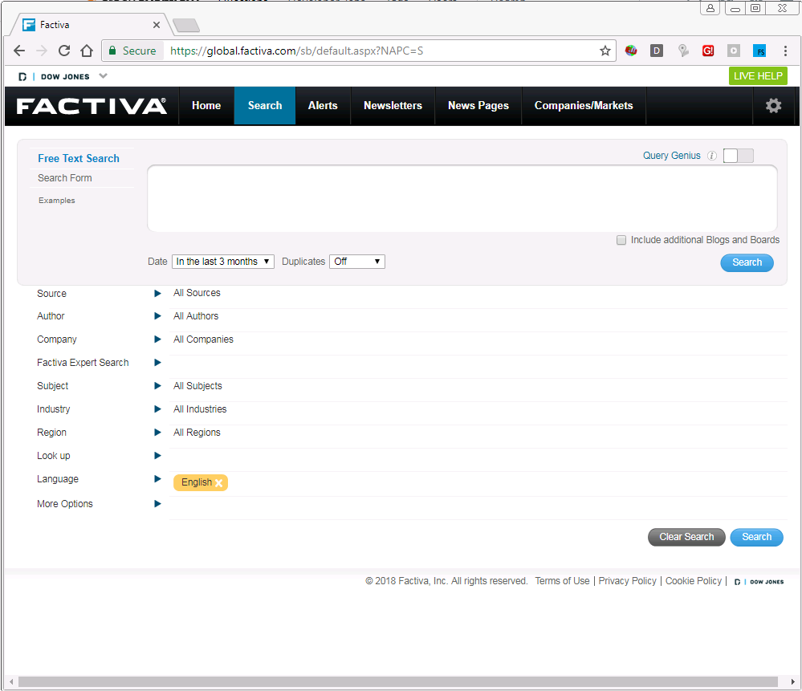

Step 3: Click on new blue FS button to launch the Chrome Extension (top right):

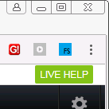

Step 4: The queries appear at the top of the screen. They are hard-coded at the moment, just two dates for Apple. (Later they will load from CSV or Excel.) Before we can use them, click the Company triangle button down the page to expand the Company search box.

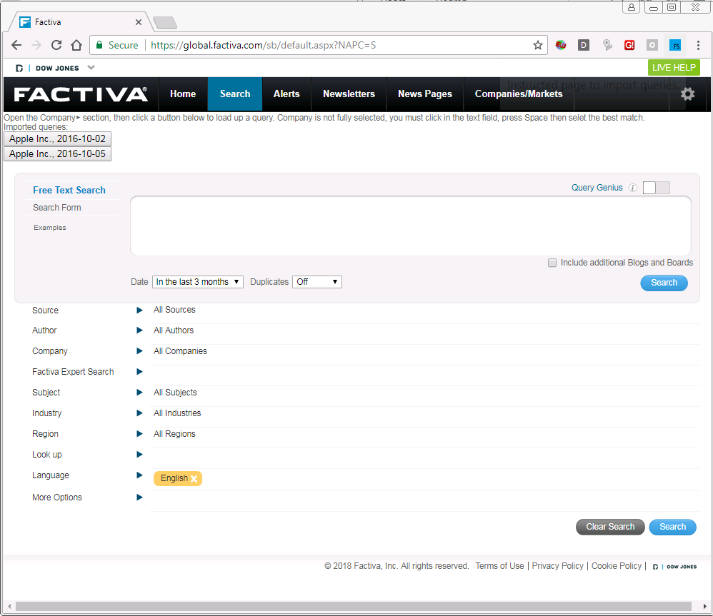

Step 5: Choose a button to load a company and date query. The date range is ready, the company is not yet ready to use.

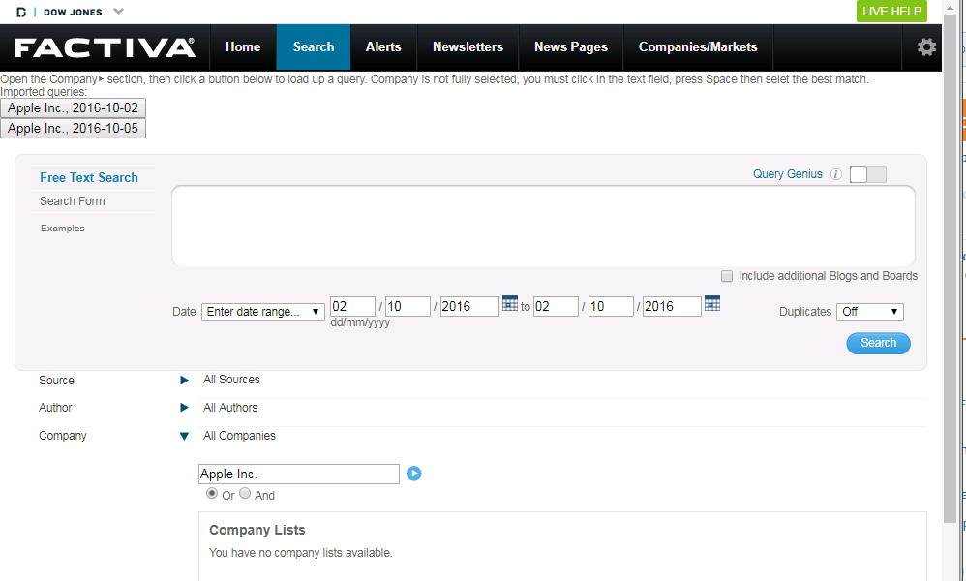

Step 6: Click in the company text field (where is says Apple Inc. Or And). Press Space to get a list of suggested companies. Click on the best (only) match (blue line). You will get a yellow company selection appearing.

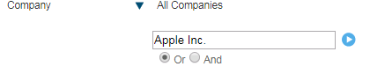🡪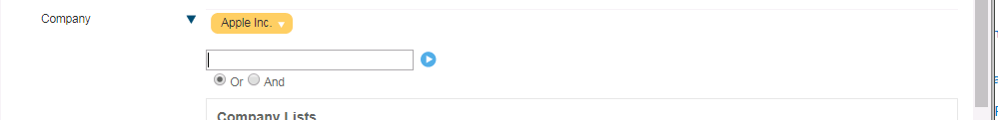

Click in text field, press Space, select match in blue (not shown). If you get a yellow company, it worked.

Step 7: We are not using keywords or publishers yet. So click the blue Search button to get results.

